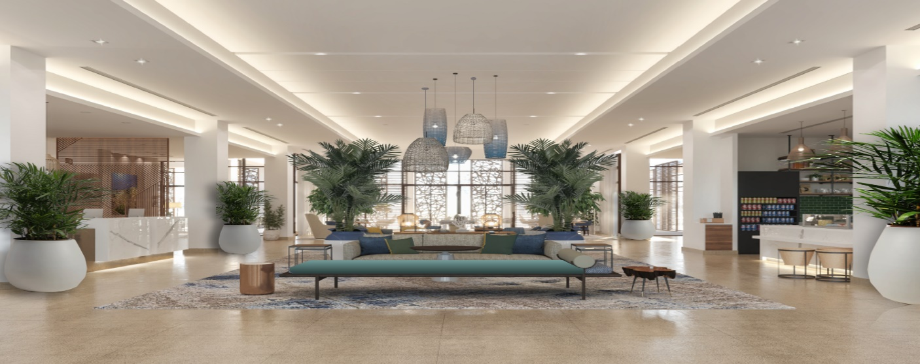

Greetings from Red Sea Global Hospitality.

Thank you for your interest in Turtle Bay Hotel.

We invite you to take a have a look at our room offering:

Arrival Date: <checkin>
Departure Date: <checkout>
Duration: <los> Nights

Your Exclusive Offer: (Plan Ahead and Save 25%)

For the dates you have requested, we are pleased to offer you the following accommodation quote:
Room Categories | Max Occupancy | Rate Per Night | Total Stay Price:  Inclusive of, 5% MT & 15% VAT
Deluxe King Room | 2 Adults | $ | $
Deluxe King Room with Garden View | 2 Adults | $ | $
Deluxe King Room with Sea View | 2 Adults | $ | $

Rates are quoted in Saudi Arabian Riyal ($) per room and include daily Breakfast.

Please note that we are currently not holding any reservation for you, please note that Room and Rates are subject to availability at the time of booking and is always subject to change without any prior notice.

Should you wish to confirm your booking at Turtle Bay Hotel, we kindly ask that you share your preferred Room type, guest names, as well as your preferred payment details to guarantee your reservation.

Terms and Conditions:

- 2 Nights Minimum Length of Stay is required.
- This offer is valid for new bookings only and cannot combined with any other offers.
- The offer is subject to change and may be discontinued at any time offer.
• Non-refundable, full cost of stay will be charged at the time of booking.
• This offer is based on the number of requested Guest and length of stay.
• Transportation rates aren’t included in the above rate.

Reservations Policy
Check-in time: 3:00 PM
Check-out time: 12:00 Noon

Early Arrivals and Late Departures

For early arrivals, we recommend booking the room for the previous night to ensure immediate access. For late departures, reserving an extra night guarantees access until you leave. If you don't opt for this, we can store your bags and provide changing-room facilities.

Additional guests and children surcharge
Subject to the maximum occupancy applicable by room, the following applies for additional guests.

Accommodation

Turtle Bay Hotel charges no additional fee for children under 12 years of age occupying the same guest room as their parents or guardians (space permitting).

Cancellation Policy

Non-refundable deposit equal to full cost of stay will be charged to credit card at time of booking. including VAT and Municipality fee. This fee also applies to non-Arrival.

Reservation Guarantee Policy

Payment of the total cost of your stay, including VAT and Municipality fee, is required at the time of booking. This amount will be charged to your Credit Card at the time of booking. If no credit card is provided, a full deposit must be made via a Secure Payment Link.

Should you require further information, please do not hesitate to contact me personally.
We would be delighted to welcome you to stay with us at Turtle Bay Hotel and look forward to your response.

Turtle Bay Hotel
Red Sea Project, Coastal Roomge, Kingdom of Saudi Arabia
Reservations@RedSeaGlobalHospitality.com
+966 9200 11099
www.turtlebayhotel.sa

